Annexes

Initial Planning Document NPA 226/519 Numbering Relief

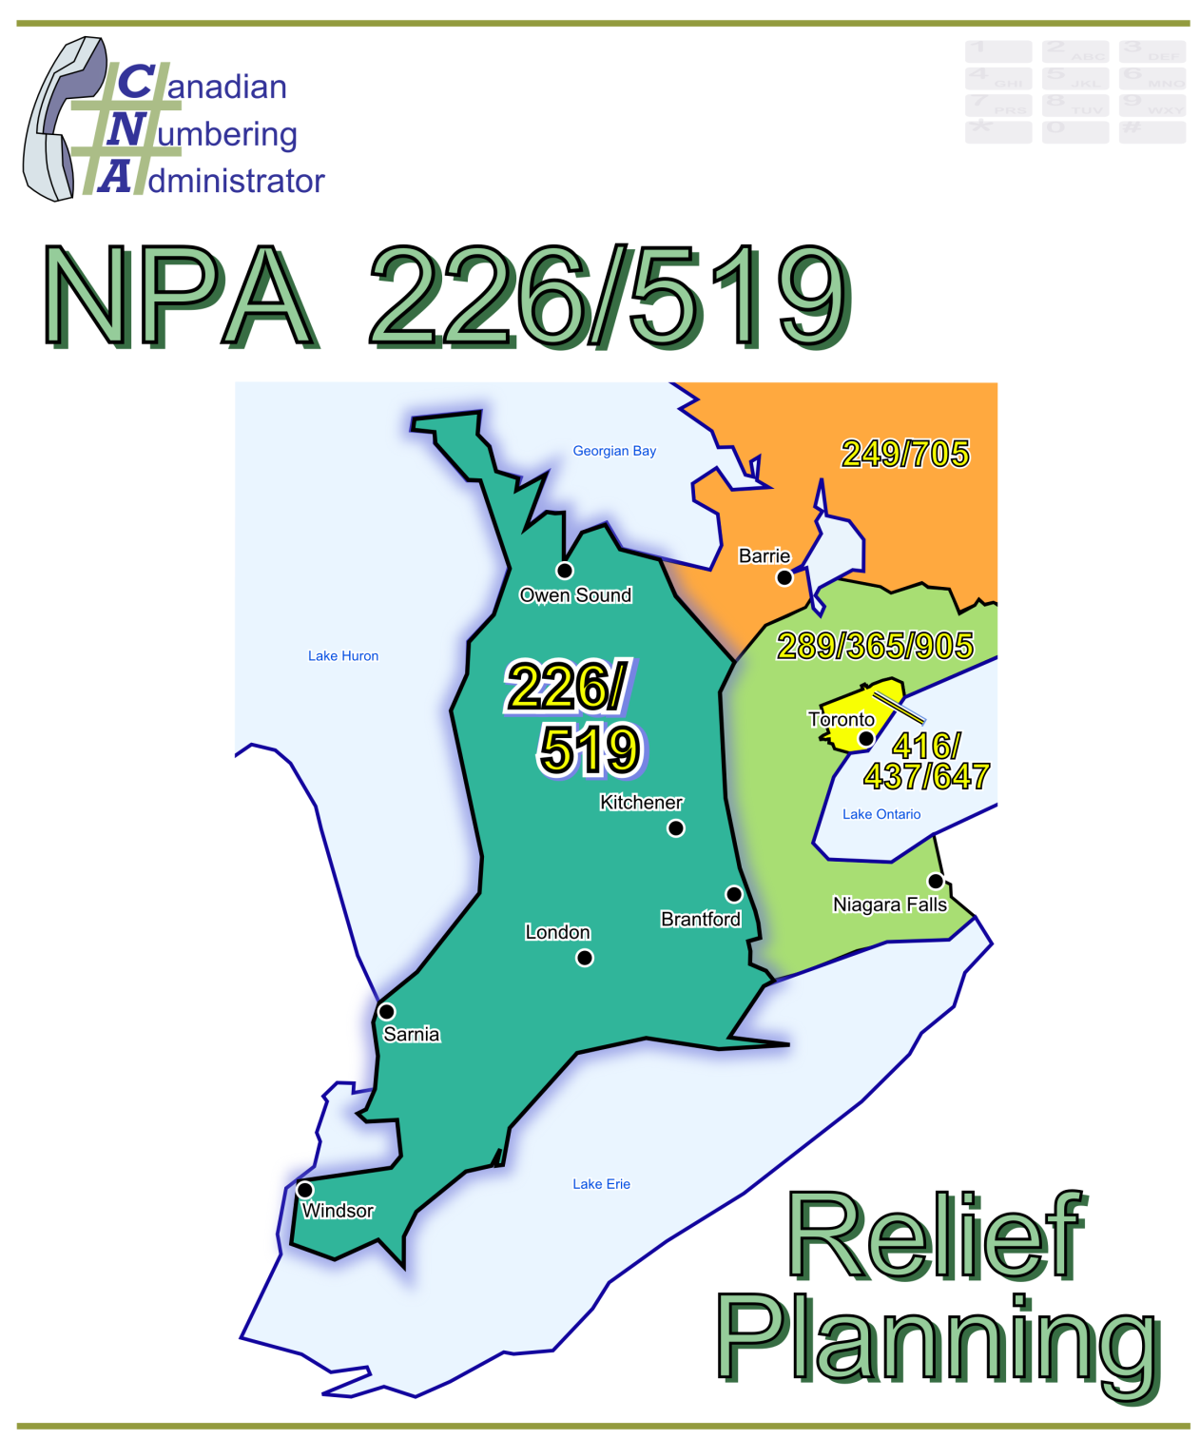

Initial Planning Document (IPD)

Version 1.0

28 February 2013

|  |  |
| --- | --- |
| Canadian Numbering Administrator (CNA)  Suresh Khare  613-683-3296  60 Queen Street, Suite 1516  Ottawa, Ontario K1P 5Y7  khares@saiccanada.com | SAICCanada_Logo_2011-07 |

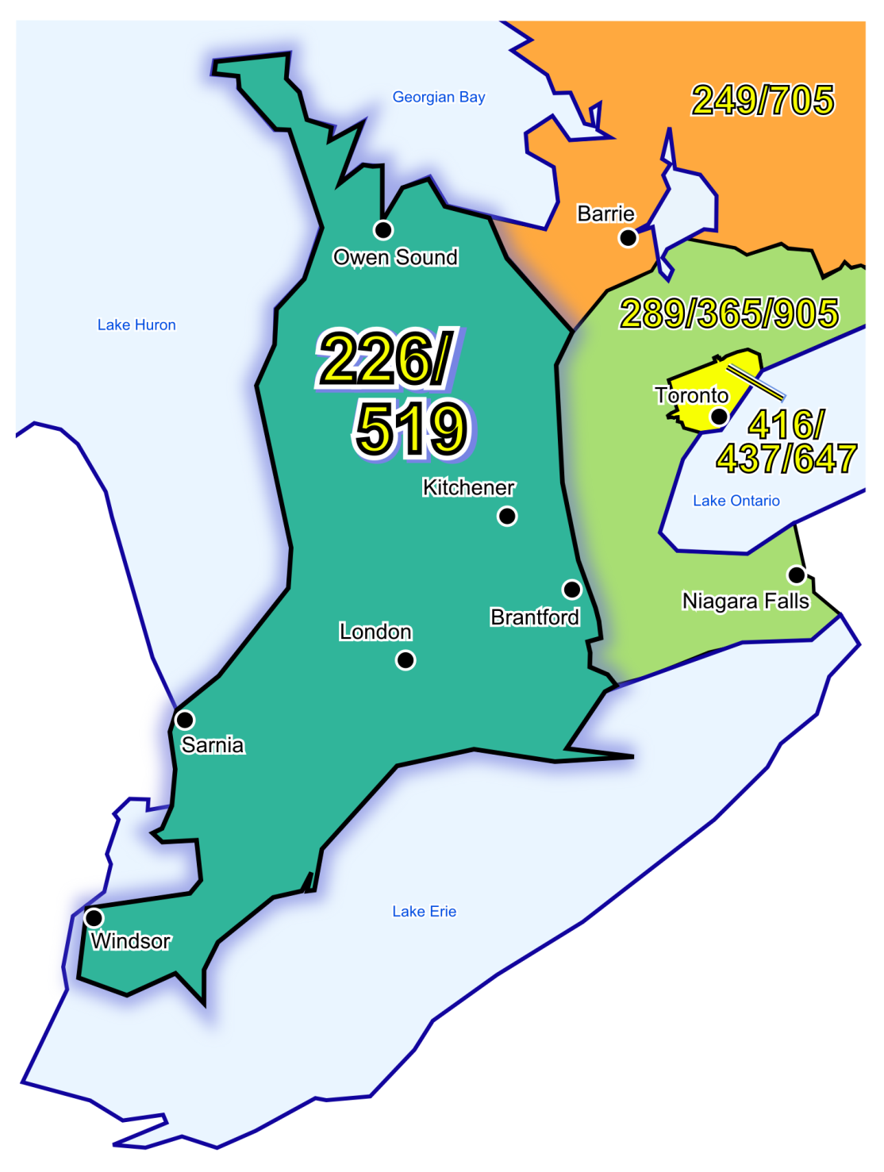

Figure 1 - Overview Map of NPA 226/519 and Adjacent NPAs



Figure 2 - NPA 226/519 Actual and Forecast CO Code Assignments

Figure 3 - NPA 226/519 CO Code Exhaust, January 2012 G-NRUF

Figure 4 - NPA 226/519 Miscellaneous and LEC+WSP CO Codes, January 2012 G‑NRUF

Figure 5 - NPA 226/519 CO Code Exhaust, July 2012 R-NRUF

Figure 6 - NPA 226/519 Miscellaneous and LEC+WSP CO Codes, July 2012 R-NRUF

Figure 7 - NPA 226/519 CO Code Exhaust, July 2012 R-NRUF (including NOC directives)

Figure 8 - NPA 226/519 Miscellaneous and LEC+WSP CO Codes, July 2012 R-NRUF (including NOC directives)

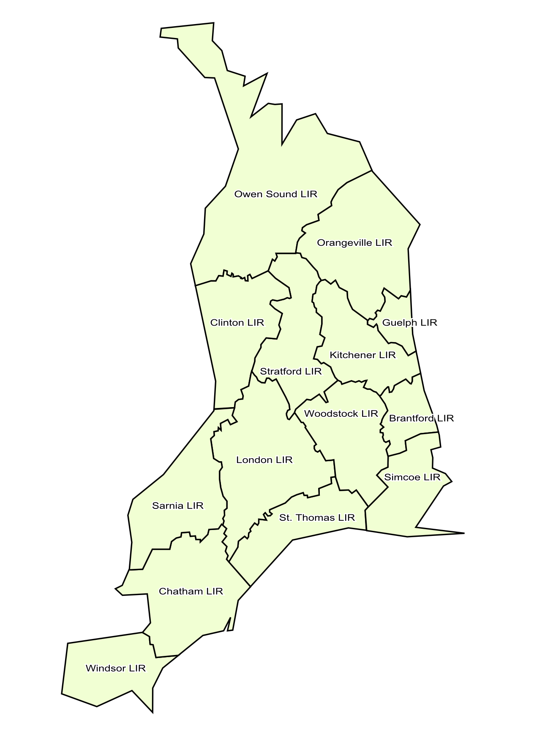

**Figure 9 - NPA 226/519 LIRs**

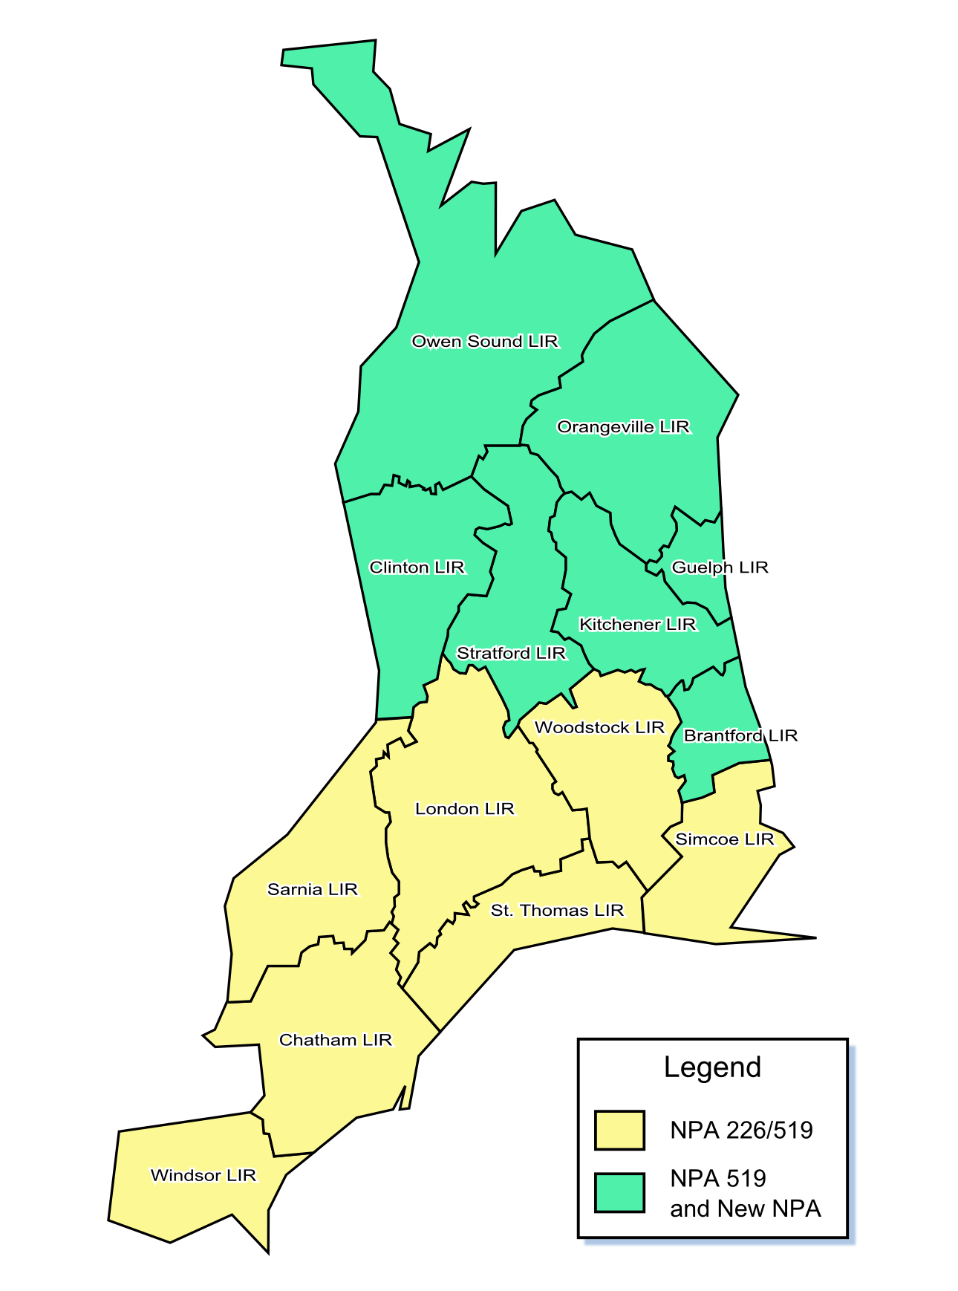

Figure 10 - Option 1: Split – North South Split of NPA 226 - South retains NPA 226

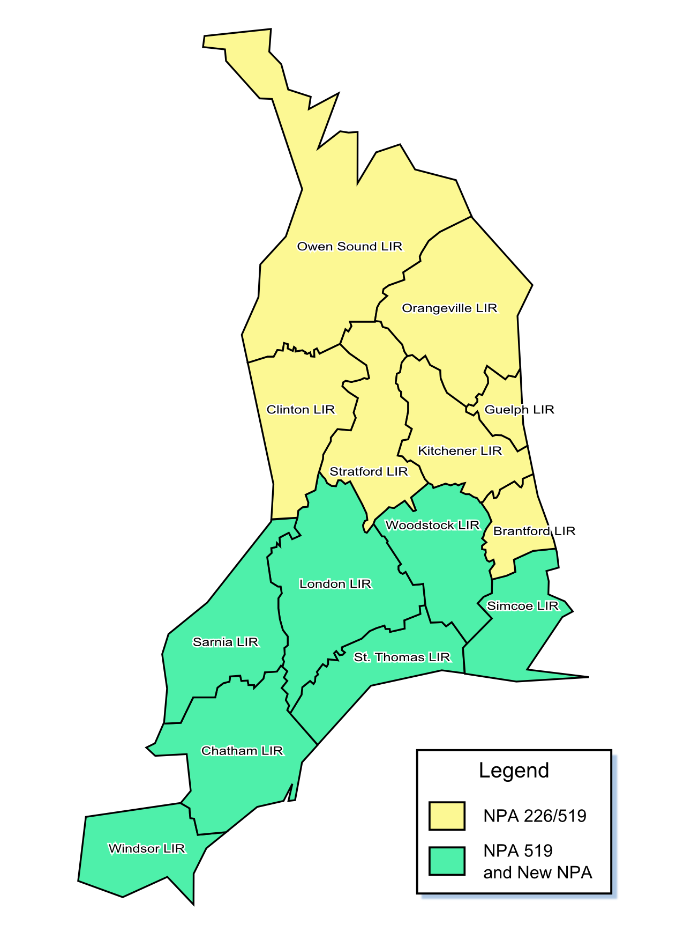

Figure 11 - Option 2: Split – North South Split of NPA 226 - North retains NPA 226

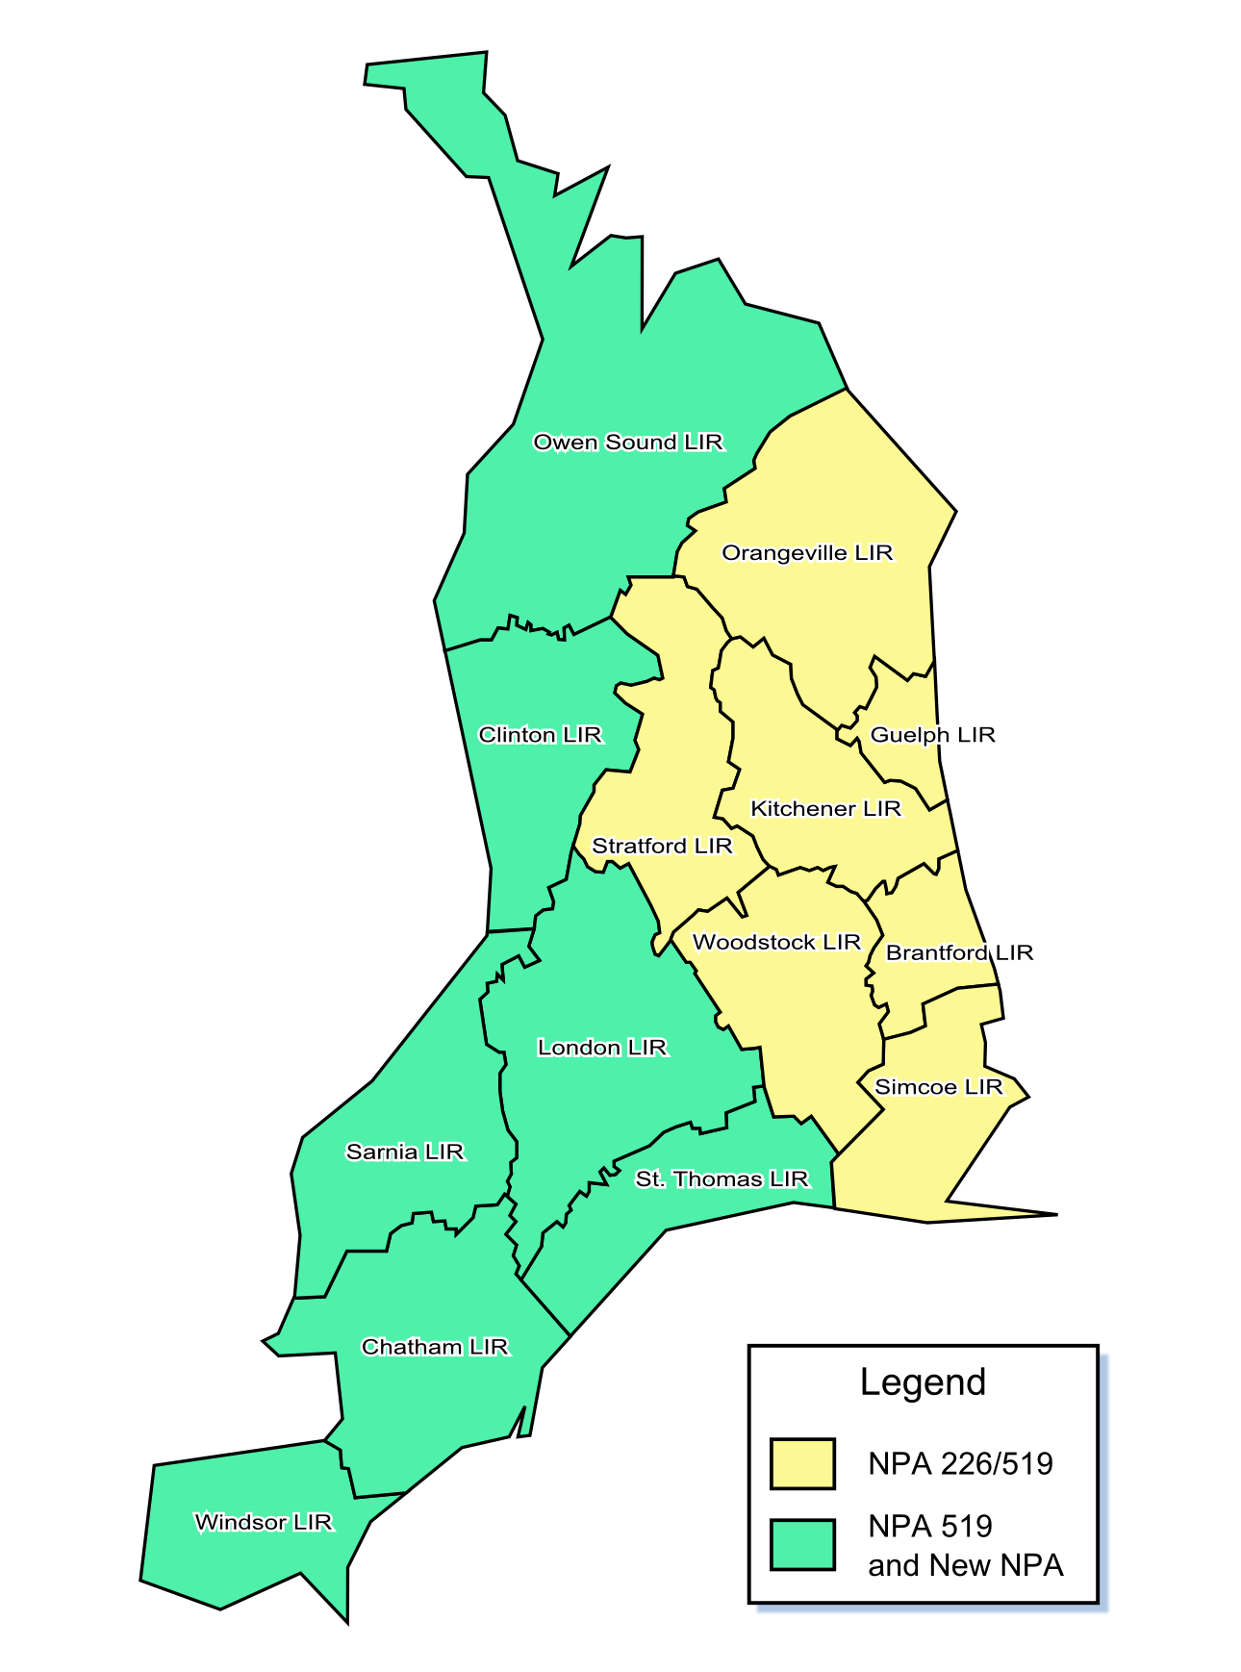

Figure 12 - Option 3: Split – East West Split of NPA 226 – East retains NPA 226

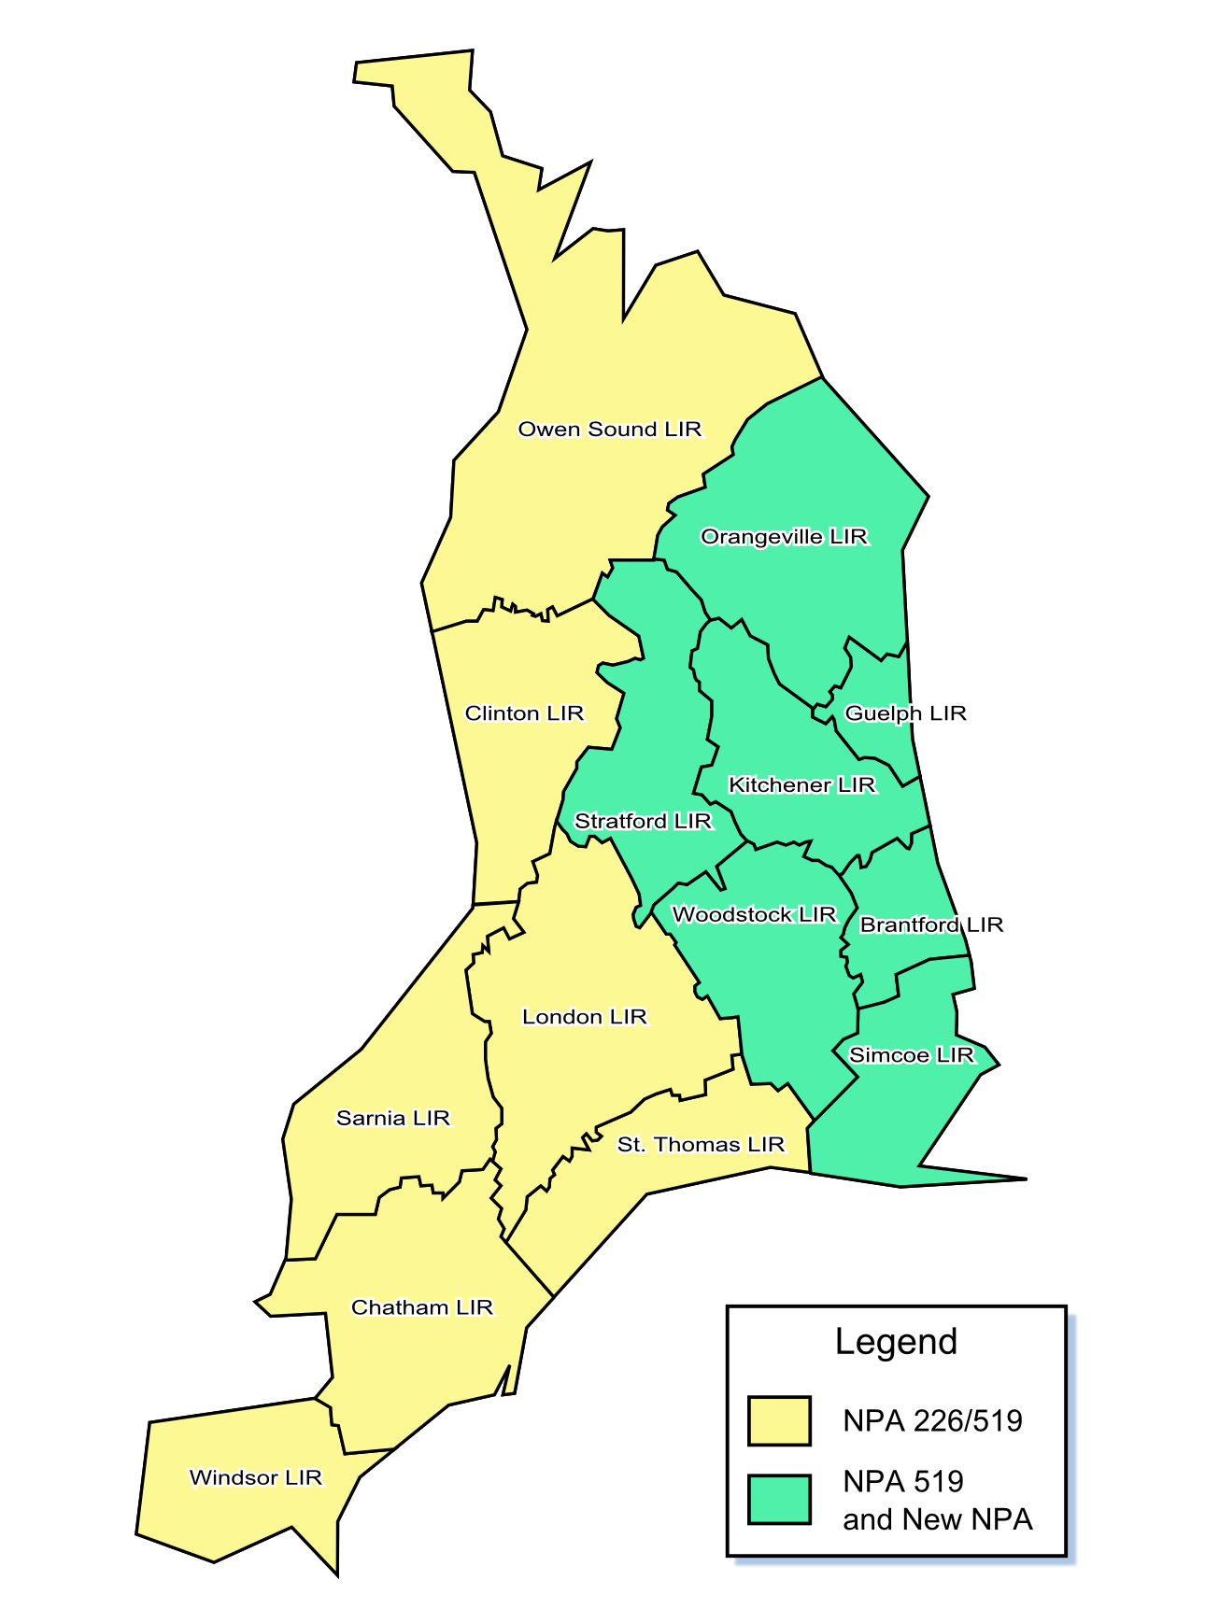

Figure 13 - Option 4: Split – East West Split of NPA 226 – West retains NPA 226

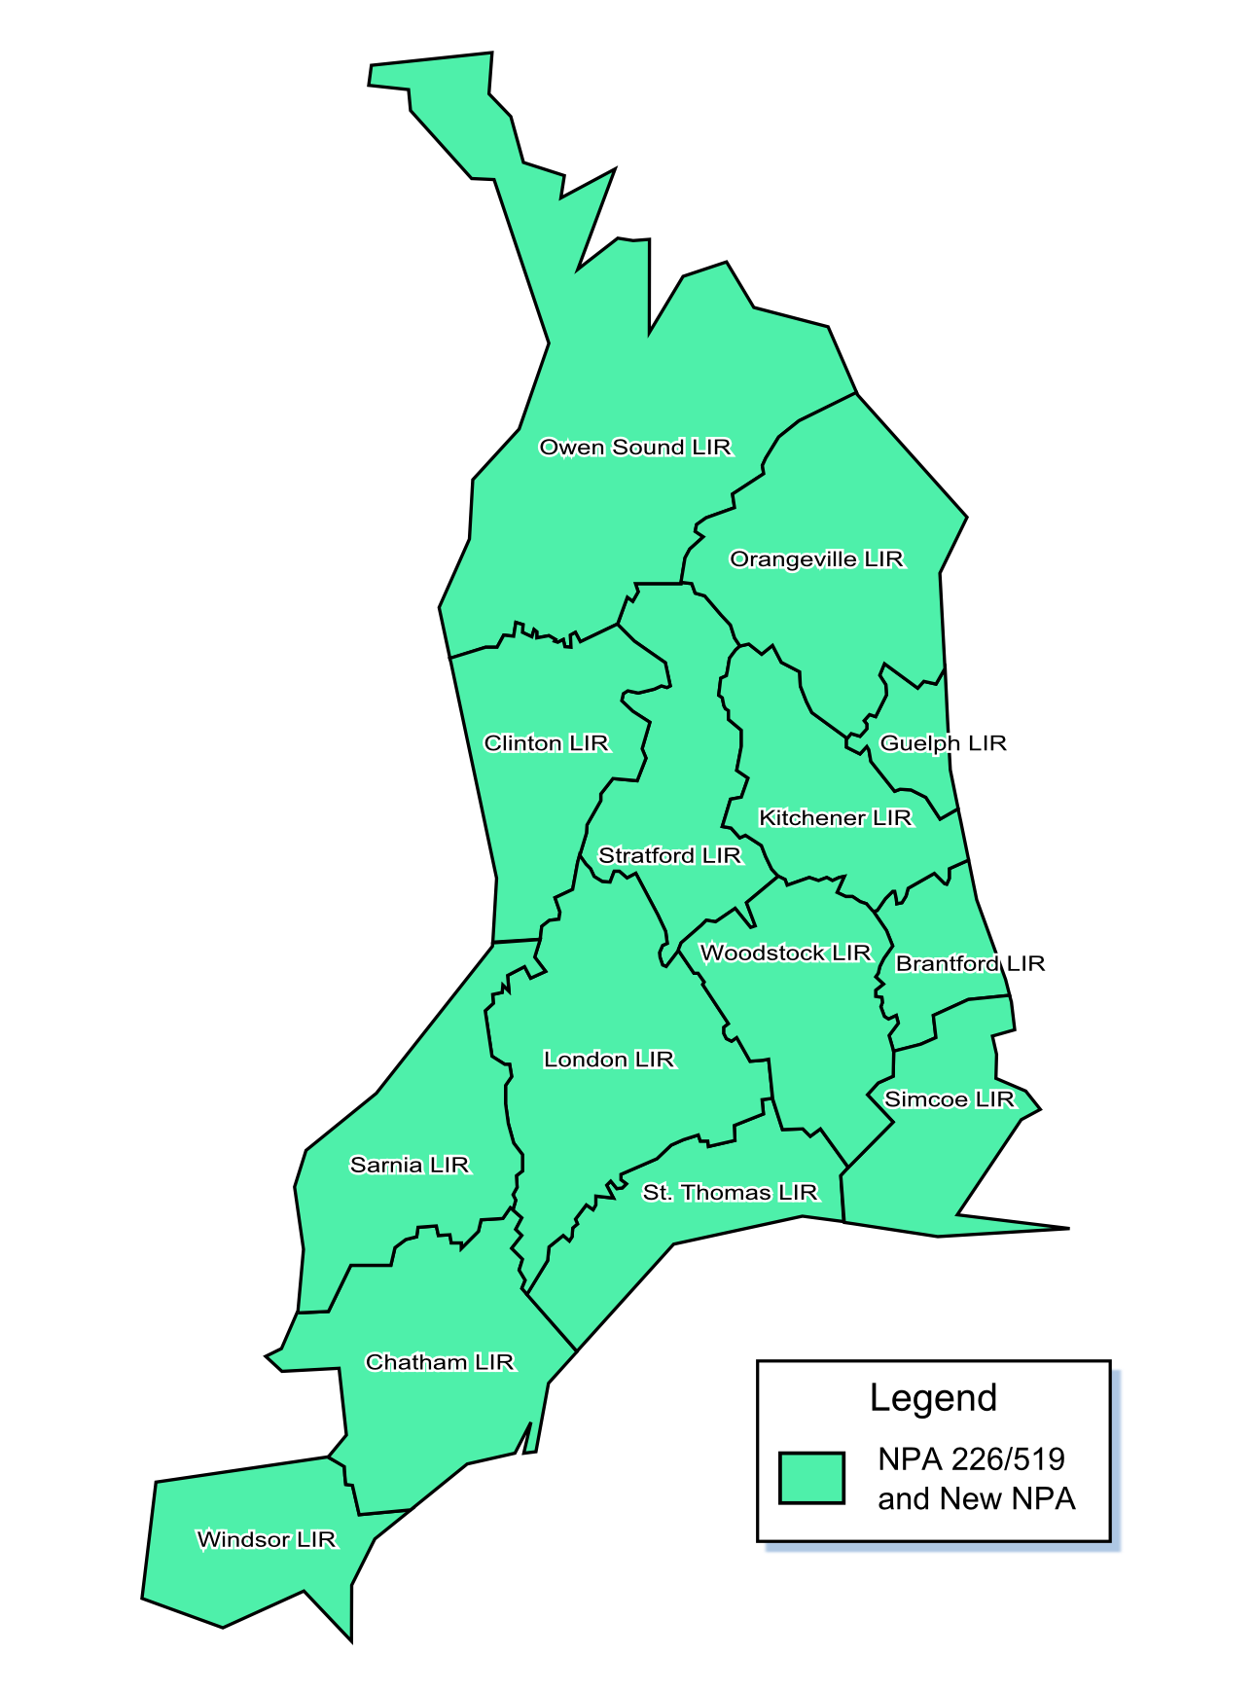

Figure 14 - Option 5: Distributed Overlay of New NPA on NPA 226/519

Table 1 – Exchange Areas currently in NPA 226/519 and NPAs for these Exchange Areas after each Relief Option

|  | **Options** | **1** | | | **2** | | | **3** | | | **4** | | | **5** | | |
| --- | --- | --- | --- | --- | --- | --- | --- | --- | --- | --- | --- | --- | --- | --- | --- | --- |
| **No.** | **Exchange Area** | **519** | **226** | **New** | **519** | **226** | **New** | **519** | **226** | **New** | **519** | **226** | **New** | **519** | **226** | **New** |
| 1 | Aberarder | ✓ | ✓ |  | ✓ |  | ✓ | ✓ |  | ✓ | ✓ | ✓ |  | ✓ | ✓ | ✓ |
| 2 | Acton | ✓ |  | ✓ | ✓ | ✓ |  | ✓ | ✓ |  | ✓ |  | ✓ | ✓ | ✓ | ✓ |
| 3 | Ailsa Craig | ✓ | ✓ |  | ✓ |  | ✓ | ✓ |  | ✓ | ✓ | ✓ |  | ✓ | ✓ | ✓ |
| 4 | Alvinston | ✓ | ✓ |  | ✓ |  | ✓ | ✓ |  | ✓ | ✓ | ✓ |  | ✓ | ✓ | ✓ |
| 5 | Alvinston Independant | ✓ | ✓ |  | ✓ |  | ✓ | ✓ |  | ✓ | ✓ | ✓ |  | ✓ | ✓ | ✓ |
| 6 | Amherstburg | ✓ | ✓ |  | ✓ |  | ✓ | ✓ |  | ✓ | ✓ | ✓ |  | ✓ | ✓ | ✓ |
| 7 | Arkona | ✓ | ✓ |  | ✓ |  | ✓ | ✓ |  | ✓ | ✓ | ✓ |  | ✓ | ✓ | ✓ |
| 8 | Arthur | ✓ |  | ✓ | ✓ | ✓ |  | ✓ | ✓ |  | ✓ |  | ✓ | ✓ | ✓ | ✓ |
| 9 | Atwood | ✓ |  | ✓ | ✓ | ✓ |  | ✓ | ✓ |  | ✓ |  | ✓ | ✓ | ✓ | ✓ |
| 10 | Auburn | ✓ |  | ✓ | ✓ | ✓ |  | ✓ |  | ✓ | ✓ | ✓ |  | ✓ | ✓ | ✓ |
| 11 | Aylmer | ✓ | ✓ |  | ✓ |  | ✓ | ✓ |  | ✓ | ✓ | ✓ |  | ✓ | ✓ | ✓ |
| 12 | Ayr | ✓ |  | ✓ | ✓ | ✓ |  | ✓ | ✓ |  | ✓ |  | ✓ | ✓ | ✓ | ✓ |
| 13 | Ayton | ✓ |  | ✓ | ✓ | ✓ |  | ✓ |  | ✓ | ✓ | ✓ |  | ✓ | ✓ | ✓ |
| 14 | Baden | ✓ |  | ✓ | ✓ | ✓ |  | ✓ | ✓ |  | ✓ |  | ✓ | ✓ | ✓ | ✓ |
| 15 | Bayfield | ✓ |  | ✓ | ✓ | ✓ |  | ✓ |  | ✓ | ✓ | ✓ |  | ✓ | ✓ | ✓ |
| 16 | Beachville | ✓ | ✓ |  | ✓ |  | ✓ | ✓ | ✓ |  | ✓ |  | ✓ | ✓ | ✓ | ✓ |
| 17 | Belle River | ✓ | ✓ |  | ✓ |  | ✓ | ✓ |  | ✓ | ✓ | ✓ |  | ✓ | ✓ | ✓ |
| 18 | Belmont | ✓ | ✓ |  | ✓ |  | ✓ | ✓ |  | ✓ | ✓ | ✓ |  | ✓ | ✓ | ✓ |
| 19 | Blenheim | ✓ | ✓ |  | ✓ |  | ✓ | ✓ |  | ✓ | ✓ | ✓ |  | ✓ | ✓ | ✓ |
| 20 | Blyth | ✓ |  | ✓ | ✓ | ✓ |  | ✓ |  | ✓ | ✓ | ✓ |  | ✓ | ✓ | ✓ |
| 21 | Bothwell | ✓ | ✓ |  | ✓ |  | ✓ | ✓ |  | ✓ | ✓ | ✓ |  | ✓ | ✓ | ✓ |
| 22 | Brantford | ✓ |  | ✓ | ✓ | ✓ |  | ✓ | ✓ |  | ✓ |  | ✓ | ✓ | ✓ | ✓ |
| 23 | Breslau | ✓ |  | ✓ | ✓ | ✓ |  | ✓ | ✓ |  | ✓ |  | ✓ | ✓ | ✓ | ✓ |
| 24 | Brigden | ✓ | ✓ |  | ✓ |  | ✓ | ✓ |  | ✓ | ✓ | ✓ |  | ✓ | ✓ | ✓ |
| 25 | Bright | ✓ | ✓ |  | ✓ |  | ✓ | ✓ | ✓ |  | ✓ |  | ✓ | ✓ | ✓ | ✓ |
| 26 | Bright's Grove | ✓ | ✓ |  | ✓ |  | ✓ | ✓ |  | ✓ | ✓ | ✓ |  | ✓ | ✓ | ✓ |
| 27 | Brownsville | ✓ | ✓ |  | ✓ |  | ✓ | ✓ | ✓ |  | ✓ |  | ✓ | ✓ | ✓ | ✓ |
| 28 | Brussels | ✓ |  | ✓ | ✓ | ✓ |  | ✓ |  | ✓ | ✓ | ✓ |  | ✓ | ✓ | ✓ |
| 29 | Burford | ✓ |  | ✓ | ✓ | ✓ |  | ✓ | ✓ |  | ✓ |  | ✓ | ✓ | ✓ | ✓ |
| 30 | Burgessville | ✓ | ✓ |  | ✓ |  | ✓ | ✓ | ✓ |  | ✓ |  | ✓ | ✓ | ✓ | ✓ |
| 31 | Caledon | ✓ |  | ✓ | ✓ | ✓ |  | ✓ | ✓ |  | ✓ |  | ✓ | ✓ | ✓ | ✓ |
| 32 | Cargill | ✓ |  | ✓ | ✓ | ✓ |  | ✓ |  | ✓ | ✓ | ✓ |  | ✓ | ✓ | ✓ |
| 33 | Centralia | ✓ | ✓ |  | ✓ |  | ✓ | ✓ |  | ✓ | ✓ | ✓ |  | ✓ | ✓ | ✓ |
| 34 | Chatham | ✓ | ✓ |  | ✓ |  | ✓ | ✓ |  | ✓ | ✓ | ✓ |  | ✓ | ✓ | ✓ |
| 35 | Chatsworth | ✓ |  | ✓ | ✓ | ✓ |  | ✓ |  | ✓ | ✓ | ✓ |  | ✓ | ✓ | ✓ |
| 36 | Chesley | ✓ |  | ✓ | ✓ | ✓ |  | ✓ |  | ✓ | ✓ | ✓ |  | ✓ | ✓ | ✓ |
| 37 | Clifford | ✓ |  | ✓ | ✓ | ✓ |  | ✓ | ✓ |  | ✓ |  | ✓ | ✓ | ✓ | ✓ |
| 38 | Clinton | ✓ |  | ✓ | ✓ | ✓ |  | ✓ |  | ✓ | ✓ | ✓ |  | ✓ | ✓ | ✓ |
| 39 | Clinton Independant | ✓ |  | ✓ | ✓ | ✓ |  | ✓ |  | ✓ | ✓ | ✓ |  | ✓ | ✓ | ✓ |
| 40 | Comber | ✓ | ✓ |  | ✓ |  | ✓ | ✓ |  | ✓ | ✓ | ✓ |  | ✓ | ✓ | ✓ |
| 41 | Corunna | ✓ | ✓ |  | ✓ |  | ✓ | ✓ |  | ✓ | ✓ | ✓ |  | ✓ | ✓ | ✓ |
| 42 | Cottam | ✓ | ✓ |  | ✓ |  | ✓ | ✓ |  | ✓ | ✓ | ✓ |  | ✓ | ✓ | ✓ |
| 43 | Courtright | ✓ | ✓ |  | ✓ |  | ✓ | ✓ |  | ✓ | ✓ | ✓ |  | ✓ | ✓ | ✓ |
| 44 | Crediton | ✓ | ✓ |  | ✓ |  | ✓ | ✓ |  | ✓ | ✓ | ✓ |  | ✓ | ✓ | ✓ |
| 45 | Dashwood | ✓ |  | ✓ | ✓ | ✓ |  | ✓ |  | ✓ | ✓ | ✓ |  | ✓ | ✓ | ✓ |
| 46 | Delhi | ✓ | ✓ |  | ✓ |  | ✓ | ✓ | ✓ |  | ✓ |  | ✓ | ✓ | ✓ | ✓ |
| 47 | Dorchester | ✓ | ✓ |  | ✓ |  | ✓ | ✓ |  | ✓ | ✓ | ✓ |  | ✓ | ✓ | ✓ |
| 48 | Drayton | ✓ |  | ✓ | ✓ | ✓ |  | ✓ | ✓ |  | ✓ |  | ✓ | ✓ | ✓ | ✓ |
| 49 | Dresden | ✓ | ✓ |  | ✓ |  | ✓ | ✓ |  | ✓ | ✓ | ✓ |  | ✓ | ✓ | ✓ |
| 50 | Drumbo | ✓ | ✓ |  | ✓ |  | ✓ | ✓ | ✓ |  | ✓ |  | ✓ | ✓ | ✓ | ✓ |
| 51 | Dublin | ✓ |  | ✓ | ✓ | ✓ |  | ✓ | ✓ |  | ✓ |  | ✓ | ✓ | ✓ | ✓ |
| 52 | Dundalk | ✓ |  | ✓ | ✓ | ✓ |  | ✓ | ✓ |  | ✓ |  | ✓ | ✓ | ✓ | ✓ |
| 53 | Dungannon | ✓ |  | ✓ | ✓ | ✓ |  | ✓ |  | ✓ | ✓ | ✓ |  | ✓ | ✓ | ✓ |
| 54 | Durham | ✓ |  | ✓ | ✓ | ✓ |  | ✓ |  | ✓ | ✓ | ✓ |  | ✓ | ✓ | ✓ |
| 55 | Dutton | ✓ | ✓ |  | ✓ |  | ✓ | ✓ |  | ✓ | ✓ | ✓ |  | ✓ | ✓ | ✓ |
| 56 | Dyer's Bay | ✓ |  | ✓ | ✓ | ✓ |  | ✓ |  | ✓ | ✓ | ✓ |  | ✓ | ✓ | ✓ |
| 57 | Eastwood | ✓ | ✓ |  | ✓ |  | ✓ | ✓ | ✓ |  | ✓ |  | ✓ | ✓ | ✓ | ✓ |
| 58 | Elmira | ✓ |  | ✓ | ✓ | ✓ |  | ✓ | ✓ |  | ✓ |  | ✓ | ✓ | ✓ | ✓ |
| 59 | Elora | ✓ |  | ✓ | ✓ | ✓ |  | ✓ | ✓ |  | ✓ |  | ✓ | ✓ | ✓ | ✓ |
| 60 | Embro | ✓ | ✓ |  | ✓ |  | ✓ | ✓ | ✓ |  | ✓ |  | ✓ | ✓ | ✓ | ✓ |
| 61 | Emeryville | ✓ | ✓ |  | ✓ |  | ✓ | ✓ |  | ✓ | ✓ | ✓ |  | ✓ | ✓ | ✓ |
| 62 | Erin | ✓ |  | ✓ | ✓ | ✓ |  | ✓ | ✓ |  | ✓ |  | ✓ | ✓ | ✓ | ✓ |
| 63 | Essex | ✓ | ✓ |  | ✓ |  | ✓ | ✓ |  | ✓ | ✓ | ✓ |  | ✓ | ✓ | ✓ |
| 64 | Exeter | ✓ | ✓ |  | ✓ |  | ✓ | ✓ |  | ✓ | ✓ | ✓ |  | ✓ | ✓ | ✓ |
| 65 | Fergus | ✓ |  | ✓ | ✓ | ✓ |  | ✓ | ✓ |  | ✓ |  | ✓ | ✓ | ✓ | ✓ |
| 66 | Feversham | ✓ |  | ✓ | ✓ | ✓ |  | ✓ |  | ✓ | ✓ | ✓ |  | ✓ | ✓ | ✓ |
| 67 | Fingal | ✓ | ✓ |  | ✓ |  | ✓ | ✓ |  | ✓ | ✓ | ✓ |  | ✓ | ✓ | ✓ |
| 68 | Flesherton | ✓ |  | ✓ | ✓ | ✓ |  | ✓ |  | ✓ | ✓ | ✓ |  | ✓ | ✓ | ✓ |
| 69 | Forest | ✓ | ✓ |  | ✓ |  | ✓ | ✓ |  | ✓ | ✓ | ✓ |  | ✓ | ✓ | ✓ |
| 70 | Galt | ✓ |  | ✓ | ✓ | ✓ |  | ✓ | ✓ |  | ✓ |  | ✓ | ✓ | ✓ | ✓ |
| 71 | Glencoe | ✓ | ✓ |  | ✓ |  | ✓ | ✓ |  | ✓ | ✓ | ✓ |  | ✓ | ✓ | ✓ |
| 72 | Goderich | ✓ |  | ✓ | ✓ | ✓ |  | ✓ |  | ✓ | ✓ | ✓ |  | ✓ | ✓ | ✓ |
| 73 | Gorrie | ✓ |  | ✓ | ✓ | ✓ |  | ✓ |  | ✓ | ✓ | ✓ |  | ✓ | ✓ | ✓ |
| 74 | Grand Bend | ✓ | ✓ |  | ✓ |  | ✓ | ✓ |  | ✓ | ✓ | ✓ |  | ✓ | ✓ | ✓ |
| 75 | Grand Valley | ✓ |  | ✓ | ✓ | ✓ |  | ✓ | ✓ |  | ✓ |  | ✓ | ✓ | ✓ | ✓ |
| 76 | Granton | ✓ | ✓ |  | ✓ |  | ✓ | ✓ |  | ✓ | ✓ | ✓ |  | ✓ | ✓ | ✓ |
| 77 | Guelph | ✓ |  | ✓ | ✓ | ✓ |  | ✓ | ✓ |  | ✓ |  | ✓ | ✓ | ✓ | ✓ |
| 78 | Hanover | ✓ |  | ✓ | ✓ | ✓ |  | ✓ |  | ✓ | ✓ | ✓ |  | ✓ | ✓ | ✓ |
| 79 | Harrietsville | ✓ | ✓ |  | ✓ |  | ✓ | ✓ |  | ✓ | ✓ | ✓ |  | ✓ | ✓ | ✓ |
| 80 | Harriston | ✓ |  | ✓ | ✓ | ✓ |  | ✓ | ✓ |  | ✓ |  | ✓ | ✓ | ✓ | ✓ |
| 81 | Harrow | ✓ | ✓ |  | ✓ |  | ✓ | ✓ |  | ✓ | ✓ | ✓ |  | ✓ | ✓ | ✓ |
| 82 | Hensall | ✓ |  | ✓ | ✓ | ✓ |  | ✓ |  | ✓ | ✓ | ✓ |  | ✓ | ✓ | ✓ |
| 83 | Hensall Independent | ✓ |  | ✓ | ✓ | ✓ |  | ✓ |  | ✓ | ✓ | ✓ |  | ✓ | ✓ | ✓ |
| 84 | Hepworth | ✓ |  | ✓ | ✓ | ✓ |  | ✓ |  | ✓ | ✓ | ✓ |  | ✓ | ✓ | ✓ |
| 85 | Hespeler | ✓ |  | ✓ | ✓ | ✓ |  | ✓ | ✓ |  | ✓ |  | ✓ | ✓ | ✓ | ✓ |
| 86 | Hickson | ✓ | ✓ |  | ✓ |  | ✓ | ✓ | ✓ |  | ✓ |  | ✓ | ✓ | ✓ | ✓ |
| 87 | Highgate | ✓ | ✓ |  | ✓ |  | ✓ | ✓ |  | ✓ | ✓ | ✓ |  | ✓ | ✓ | ✓ |
| 88 | Hillsburgh | ✓ |  | ✓ | ✓ | ✓ |  | ✓ | ✓ |  | ✓ |  | ✓ | ✓ | ✓ | ✓ |
| 89 | Holstein | ✓ |  | ✓ | ✓ | ✓ |  | ✓ | ✓ |  | ✓ |  | ✓ | ✓ | ✓ | ✓ |
| 90 | Ilderton | ✓ | ✓ |  | ✓ |  | ✓ | ✓ |  | ✓ | ✓ | ✓ |  | ✓ | ✓ | ✓ |
| 91 | Ingersoll | ✓ | ✓ |  | ✓ |  | ✓ | ✓ | ✓ |  | ✓ |  | ✓ | ✓ | ✓ | ✓ |
| 92 | Innerkip | ✓ | ✓ |  | ✓ |  | ✓ | ✓ | ✓ |  | ✓ |  | ✓ | ✓ | ✓ | ✓ |
| 93 | Inwood Independant | ✓ | ✓ |  | ✓ |  | ✓ | ✓ |  | ✓ | ✓ | ✓ |  | ✓ | ✓ | ✓ |
| 94 | Jarvis | ✓ | ✓ |  | ✓ |  | ✓ | ✓ | ✓ |  | ✓ |  | ✓ | ✓ | ✓ | ✓ |
| 95 | Kerwood | ✓ | ✓ |  | ✓ |  | ✓ | ✓ |  | ✓ | ✓ | ✓ |  | ✓ | ✓ | ✓ |
| 96 | Kincardine | ✓ |  | ✓ | ✓ | ✓ |  | ✓ |  | ✓ | ✓ | ✓ |  | ✓ | ✓ | ✓ |
| 97 | Kingsville | ✓ | ✓ |  | ✓ |  | ✓ | ✓ |  | ✓ | ✓ | ✓ |  | ✓ | ✓ | ✓ |
| 98 | Kintore | ✓ | ✓ |  | ✓ |  | ✓ | ✓ | ✓ |  | ✓ |  | ✓ | ✓ | ✓ | ✓ |
| 99 | Kirkton | ✓ |  | ✓ | ✓ | ✓ |  | ✓ |  | ✓ | ✓ | ✓ |  | ✓ | ✓ | ✓ |
| 100 | Kitchener-Waterloo | ✓ |  | ✓ | ✓ | ✓ |  | ✓ | ✓ |  | ✓ |  | ✓ | ✓ | ✓ | ✓ |
| 101 | La Salle | ✓ | ✓ |  | ✓ |  | ✓ | ✓ |  | ✓ | ✓ | ✓ |  | ✓ | ✓ | ✓ |
| 102 | Lambeth | ✓ | ✓ |  | ✓ |  | ✓ | ✓ |  | ✓ | ✓ | ✓ |  | ✓ | ✓ | ✓ |
| 103 | Langton | ✓ | ✓ |  | ✓ |  | ✓ | ✓ | ✓ |  | ✓ |  | ✓ | ✓ | ✓ | ✓ |
| 104 | Leamington | ✓ | ✓ |  | ✓ |  | ✓ | ✓ |  | ✓ | ✓ | ✓ |  | ✓ | ✓ | ✓ |
| 105 | Linwood | ✓ |  | ✓ | ✓ | ✓ |  | ✓ | ✓ |  | ✓ |  | ✓ | ✓ | ✓ | ✓ |
| 106 | Lions Head | ✓ |  | ✓ | ✓ | ✓ |  | ✓ |  | ✓ | ✓ | ✓ |  | ✓ | ✓ | ✓ |
| 107 | Listowel | ✓ |  | ✓ | ✓ | ✓ |  | ✓ | ✓ |  | ✓ |  | ✓ | ✓ | ✓ | ✓ |
| 108 | London | ✓ | ✓ |  | ✓ |  | ✓ | ✓ |  | ✓ | ✓ | ✓ |  | ✓ | ✓ | ✓ |
| 109 | Lucan | ✓ | ✓ |  | ✓ |  | ✓ | ✓ |  | ✓ | ✓ | ✓ |  | ✓ | ✓ | ✓ |
| 110 | Lucknow | ✓ |  | ✓ | ✓ | ✓ |  | ✓ |  | ✓ | ✓ | ✓ |  | ✓ | ✓ | ✓ |
| 111 | Lynden | ✓ |  | ✓ | ✓ | ✓ |  | ✓ | ✓ |  | ✓ |  | ✓ | ✓ | ✓ | ✓ |
| 112 | Maidstone | ✓ | ✓ |  | ✓ |  | ✓ | ✓ |  | ✓ | ✓ | ✓ |  | ✓ | ✓ | ✓ |
| 113 | Markdale | ✓ |  | ✓ | ✓ | ✓ |  | ✓ |  | ✓ | ✓ | ✓ |  | ✓ | ✓ | ✓ |
| 114 | McGregor | ✓ | ✓ |  | ✓ |  | ✓ | ✓ |  | ✓ | ✓ | ✓ |  | ✓ | ✓ | ✓ |
| 115 | Meaford | ✓ |  | ✓ | ✓ | ✓ |  | ✓ |  | ✓ | ✓ | ✓ |  | ✓ | ✓ | ✓ |
| 116 | Melbourne | ✓ | ✓ |  | ✓ |  | ✓ | ✓ |  | ✓ | ✓ | ✓ |  | ✓ | ✓ | ✓ |
| 117 | Merlin | ✓ | ✓ |  | ✓ |  | ✓ | ✓ |  | ✓ | ✓ | ✓ |  | ✓ | ✓ | ✓ |
| 118 | Mildmay | ✓ |  | ✓ | ✓ | ✓ |  | ✓ |  | ✓ | ✓ | ✓ |  | ✓ | ✓ | ✓ |
| 119 | Milverton | ✓ |  | ✓ | ✓ | ✓ |  | ✓ | ✓ |  | ✓ |  | ✓ | ✓ | ✓ | ✓ |
| 120 | Mitchell | ✓ |  | ✓ | ✓ | ✓ |  | ✓ | ✓ |  | ✓ |  | ✓ | ✓ | ✓ | ✓ |
| 121 | Monkton | ✓ |  | ✓ | ✓ | ✓ |  | ✓ | ✓ |  | ✓ |  | ✓ | ✓ | ✓ | ✓ |
| 122 | Mount Brydges | ✓ | ✓ |  | ✓ |  | ✓ | ✓ |  | ✓ | ✓ | ✓ |  | ✓ | ✓ | ✓ |
| 123 | Mount Forest | ✓ |  | ✓ | ✓ | ✓ |  | ✓ | ✓ |  | ✓ |  | ✓ | ✓ | ✓ | ✓ |
| 124 | Mount Pleasant | ✓ |  | ✓ | ✓ | ✓ |  | ✓ | ✓ |  | ✓ |  | ✓ | ✓ | ✓ | ✓ |
| 125 | Nairn | ✓ | ✓ |  | ✓ |  | ✓ | ✓ |  | ✓ | ✓ | ✓ |  | ✓ | ✓ | ✓ |
| 126 | Neustadt | ✓ |  | ✓ | ✓ | ✓ |  | ✓ |  | ✓ | ✓ | ✓ |  | ✓ | ✓ | ✓ |
| 127 | New Dundee | ✓ |  | ✓ | ✓ | ✓ |  | ✓ | ✓ |  | ✓ |  | ✓ | ✓ | ✓ | ✓ |
| 128 | New Hamburg | ✓ |  | ✓ | ✓ | ✓ |  | ✓ | ✓ |  | ✓ |  | ✓ | ✓ | ✓ | ✓ |
| 129 | Norwich | ✓ | ✓ |  | ✓ |  | ✓ | ✓ | ✓ |  | ✓ |  | ✓ | ✓ | ✓ | ✓ |
| 130 | Norwich Independent | ✓ |  | ✓ | ✓ | ✓ |  | ✓ | ✓ |  | ✓ |  | ✓ | ✓ | ✓ | ✓ |
| 131 | Ohsweken | ✓ |  | ✓ | ✓ | ✓ |  | ✓ | ✓ |  | ✓ |  | ✓ | ✓ | ✓ | ✓ |
| 132 | Oil Springs | ✓ | ✓ |  | ✓ |  | ✓ | ✓ |  | ✓ | ✓ | ✓ |  | ✓ | ✓ | ✓ |
| 133 | Orangeville | ✓ |  | ✓ | ✓ | ✓ |  | ✓ | ✓ |  | ✓ |  | ✓ | ✓ | ✓ | ✓ |
| 134 | Otterville | ✓ | ✓ |  | ✓ |  | ✓ | ✓ | ✓ |  | ✓ |  | ✓ | ✓ | ✓ | ✓ |
| 135 | Owen Sound | ✓ |  | ✓ | ✓ | ✓ |  | ✓ |  | ✓ | ✓ | ✓ |  | ✓ | ✓ | ✓ |
| 136 | Paisley | ✓ |  | ✓ | ✓ | ✓ |  | ✓ |  | ✓ | ✓ | ✓ |  | ✓ | ✓ | ✓ |
| 137 | Palmerston | ✓ |  | ✓ | ✓ | ✓ |  | ✓ | ✓ |  | ✓ |  | ✓ | ✓ | ✓ | ✓ |
| 138 | Paris | ✓ |  | ✓ | ✓ | ✓ |  | ✓ | ✓ |  | ✓ |  | ✓ | ✓ | ✓ | ✓ |
| 139 | Parkhill | ✓ | ✓ |  | ✓ |  | ✓ | ✓ |  | ✓ | ✓ | ✓ |  | ✓ | ✓ | ✓ |
| 140 | Pelee Island | ✓ | ✓ |  | ✓ |  | ✓ | ✓ |  | ✓ | ✓ | ✓ |  | ✓ | ✓ | ✓ |
| 141 | Petrolia | ✓ | ✓ |  | ✓ |  | ✓ | ✓ |  | ✓ | ✓ | ✓ |  | ✓ | ✓ | ✓ |
| 142 | Plattsville | ✓ |  | ✓ | ✓ | ✓ |  | ✓ | ✓ |  | ✓ |  | ✓ | ✓ | ✓ | ✓ |
| 143 | Pleasant Park | ✓ | ✓ |  | ✓ |  | ✓ | ✓ |  | ✓ | ✓ | ✓ |  | ✓ | ✓ | ✓ |
| 144 | Port Burwell | ✓ | ✓ |  | ✓ |  | ✓ | ✓ |  | ✓ | ✓ | ✓ |  | ✓ | ✓ | ✓ |
| 145 | Port Dover | ✓ | ✓ |  | ✓ |  | ✓ | ✓ | ✓ |  | ✓ |  | ✓ | ✓ | ✓ | ✓ |
| 146 | Port Elgin | ✓ |  | ✓ | ✓ | ✓ |  | ✓ |  | ✓ | ✓ | ✓ |  | ✓ | ✓ | ✓ |
| 147 | Port Franks | ✓ | ✓ |  | ✓ |  | ✓ | ✓ |  | ✓ | ✓ | ✓ |  | ✓ | ✓ | ✓ |
| 148 | Port Lambton | ✓ | ✓ |  | ✓ |  | ✓ | ✓ |  | ✓ | ✓ | ✓ |  | ✓ | ✓ | ✓ |
| 149 | Port Rowan | ✓ | ✓ |  | ✓ |  | ✓ | ✓ | ✓ |  | ✓ |  | ✓ | ✓ | ✓ | ✓ |
| 150 | Port Stanley | ✓ | ✓ |  | ✓ |  | ✓ | ✓ |  | ✓ | ✓ | ✓ |  | ✓ | ✓ | ✓ |
| 151 | Preston | ✓ |  | ✓ | ✓ | ✓ |  | ✓ | ✓ |  | ✓ |  | ✓ | ✓ | ✓ | ✓ |
| 152 | Princeton | ✓ | ✓ |  | ✓ |  | ✓ | ✓ | ✓ |  | ✓ |  | ✓ | ✓ | ✓ | ✓ |
| 153 | Ridgetown | ✓ | ✓ |  | ✓ |  | ✓ | ✓ |  | ✓ | ✓ | ✓ |  | ✓ | ✓ | ✓ |
| 154 | Ripley | ✓ |  | ✓ | ✓ | ✓ |  | ✓ |  | ✓ | ✓ | ✓ |  | ✓ | ✓ | ✓ |
| 155 | Rockwood | ✓ |  | ✓ | ✓ | ✓ |  | ✓ | ✓ |  | ✓ |  | ✓ | ✓ | ✓ | ✓ |
| 156 | Rodney | ✓ | ✓ |  | ✓ |  | ✓ | ✓ |  | ✓ | ✓ | ✓ |  | ✓ | ✓ | ✓ |
| 157 | Sarnia | ✓ | ✓ |  | ✓ |  | ✓ | ✓ |  | ✓ | ✓ | ✓ |  | ✓ | ✓ | ✓ |
| 158 | Sauble Beach | ✓ |  | ✓ | ✓ | ✓ |  | ✓ |  | ✓ | ✓ | ✓ |  | ✓ | ✓ | ✓ |
| 159 | Scotland | ✓ |  | ✓ | ✓ | ✓ |  | ✓ | ✓ |  | ✓ |  | ✓ | ✓ | ✓ | ✓ |
| 160 | Seaforth | ✓ |  | ✓ | ✓ | ✓ |  | ✓ |  | ✓ | ✓ | ✓ |  | ✓ | ✓ | ✓ |
| 161 | Seaforth Independant | ✓ |  | ✓ | ✓ | ✓ |  | ✓ |  | ✓ | ✓ | ✓ |  | ✓ | ✓ | ✓ |
| 162 | Sebringville | ✓ |  | ✓ | ✓ | ✓ |  | ✓ | ✓ |  | ✓ |  | ✓ | ✓ | ✓ | ✓ |
| 163 | Shakespeare | ✓ |  | ✓ | ✓ | ✓ |  | ✓ | ✓ |  | ✓ |  | ✓ | ✓ | ✓ | ✓ |
| 164 | Shedden | ✓ | ✓ |  | ✓ |  | ✓ | ✓ |  | ✓ | ✓ | ✓ |  | ✓ | ✓ | ✓ |
| 165 | Shelburne | ✓ |  | ✓ | ✓ | ✓ |  | ✓ | ✓ |  | ✓ |  | ✓ | ✓ | ✓ | ✓ |
| 166 | Simcoe | ✓ | ✓ |  | ✓ |  | ✓ | ✓ | ✓ |  | ✓ |  | ✓ | ✓ | ✓ | ✓ |
| 167 | Sombra | ✓ | ✓ |  | ✓ |  | ✓ | ✓ |  | ✓ | ✓ | ✓ |  | ✓ | ✓ | ✓ |
| 168 | Southampton | ✓ |  | ✓ | ✓ | ✓ |  | ✓ |  | ✓ | ✓ | ✓ |  | ✓ | ✓ | ✓ |
| 169 | Sparta | ✓ | ✓ |  | ✓ |  | ✓ | ✓ |  | ✓ | ✓ | ✓ |  | ✓ | ✓ | ✓ |
| 170 | St. Clements | ✓ |  | ✓ | ✓ | ✓ |  | ✓ | ✓ |  | ✓ |  | ✓ | ✓ | ✓ | ✓ |
| 171 | St. George | ✓ |  | ✓ | ✓ | ✓ |  | ✓ | ✓ |  | ✓ |  | ✓ | ✓ | ✓ | ✓ |
| 172 | St. Jacobs | ✓ |  | ✓ | ✓ | ✓ |  | ✓ | ✓ |  | ✓ |  | ✓ | ✓ | ✓ | ✓ |
| 173 | St. Marys | ✓ |  | ✓ | ✓ | ✓ |  | ✓ | ✓ |  | ✓ |  | ✓ | ✓ | ✓ | ✓ |
| 174 | St. Thomas | ✓ | ✓ |  | ✓ |  | ✓ | ✓ |  | ✓ | ✓ | ✓ |  | ✓ | ✓ | ✓ |
| 175 | Stokes Bay | ✓ |  | ✓ | ✓ | ✓ |  | ✓ |  | ✓ | ✓ | ✓ |  | ✓ | ✓ | ✓ |
| 176 | Stoney Point | ✓ | ✓ |  | ✓ |  | ✓ | ✓ |  | ✓ | ✓ | ✓ |  | ✓ | ✓ | ✓ |
| 177 | Straffordville | ✓ | ✓ |  | ✓ |  | ✓ | ✓ |  | ✓ | ✓ | ✓ |  | ✓ | ✓ | ✓ |
| 178 | Stratford | ✓ |  | ✓ | ✓ | ✓ |  | ✓ | ✓ |  | ✓ |  | ✓ | ✓ | ✓ | ✓ |
| 179 | Strathroy | ✓ | ✓ |  | ✓ |  | ✓ | ✓ |  | ✓ | ✓ | ✓ |  | ✓ | ✓ | ✓ |
| 180 | Tara | ✓ |  | ✓ | ✓ | ✓ |  | ✓ |  | ✓ | ✓ | ✓ |  | ✓ | ✓ | ✓ |
| 181 | Tavistock | ✓ |  | ✓ | ✓ | ✓ |  | ✓ | ✓ |  | ✓ |  | ✓ | ✓ | ✓ | ✓ |
| 182 | Tecumseh | ✓ | ✓ |  | ✓ |  | ✓ | ✓ |  | ✓ | ✓ | ✓ |  | ✓ | ✓ | ✓ |
| 183 | Teeswater | ✓ |  | ✓ | ✓ | ✓ |  | ✓ |  | ✓ | ✓ | ✓ |  | ✓ | ✓ | ✓ |
| 184 | Thamesford | ✓ | ✓ |  | ✓ |  | ✓ | ✓ | ✓ |  | ✓ |  | ✓ | ✓ | ✓ | ✓ |
| 185 | Thamesville | ✓ | ✓ |  | ✓ |  | ✓ | ✓ |  | ✓ | ✓ | ✓ |  | ✓ | ✓ | ✓ |
| 186 | Thedford | ✓ | ✓ |  | ✓ |  | ✓ | ✓ |  | ✓ | ✓ | ✓ |  | ✓ | ✓ | ✓ |
| 187 | Thornbury | ✓ |  | ✓ | ✓ | ✓ |  | ✓ |  | ✓ | ✓ | ✓ |  | ✓ | ✓ | ✓ |
| 188 | Thorndale | ✓ | ✓ |  | ✓ |  | ✓ | ✓ |  | ✓ | ✓ | ✓ |  | ✓ | ✓ | ✓ |
| 189 | Tilbury | ✓ | ✓ |  | ✓ |  | ✓ | ✓ |  | ✓ | ✓ | ✓ |  | ✓ | ✓ | ✓ |
| 190 | Tillsonburg | ✓ | ✓ |  | ✓ |  | ✓ | ✓ | ✓ |  | ✓ |  | ✓ | ✓ | ✓ | ✓ |
| 191 | Tiverton | ✓ |  | ✓ | ✓ | ✓ |  | ✓ |  | ✓ | ✓ | ✓ |  | ✓ | ✓ | ✓ |
| 192 | Tobermory | ✓ |  | ✓ | ✓ | ✓ |  | ✓ |  | ✓ | ✓ | ✓ |  | ✓ | ✓ | ✓ |
| 193 | Uniondale | ✓ | ✓ |  | ✓ |  | ✓ | ✓ | ✓ |  | ✓ |  | ✓ | ✓ | ✓ | ✓ |
| 194 | Walkerton | ✓ |  | ✓ | ✓ | ✓ |  | ✓ |  | ✓ | ✓ | ✓ |  | ✓ | ✓ | ✓ |
| 195 | Wallaceburg | ✓ | ✓ |  | ✓ |  | ✓ | ✓ |  | ✓ | ✓ | ✓ |  | ✓ | ✓ | ✓ |
| 196 | Wardsville | ✓ | ✓ |  | ✓ |  | ✓ | ✓ |  | ✓ | ✓ | ✓ |  | ✓ | ✓ | ✓ |
| 197 | Waterford | ✓ | ✓ |  | ✓ |  | ✓ | ✓ | ✓ |  | ✓ |  | ✓ | ✓ | ✓ | ✓ |
| 198 | Watford | ✓ | ✓ |  | ✓ |  | ✓ | ✓ |  | ✓ | ✓ | ✓ |  | ✓ | ✓ | ✓ |
| 199 | Watford Independent | ✓ | ✓ |  | ✓ |  | ✓ | ✓ |  | ✓ | ✓ | ✓ |  | ✓ | ✓ | ✓ |
| 200 | Wellesley | ✓ |  | ✓ | ✓ | ✓ |  | ✓ | ✓ |  | ✓ |  | ✓ | ✓ | ✓ | ✓ |
| 201 | West Lorne | ✓ | ✓ |  | ✓ |  | ✓ | ✓ |  | ✓ | ✓ | ✓ |  | ✓ | ✓ | ✓ |
| 202 | Wheatley | ✓ | ✓ |  | ✓ |  | ✓ | ✓ |  | ✓ | ✓ | ✓ |  | ✓ | ✓ | ✓ |
| 203 | Wiarton | ✓ |  | ✓ | ✓ | ✓ |  | ✓ |  | ✓ | ✓ | ✓ |  | ✓ | ✓ | ✓ |
| 204 | Windsor | ✓ | ✓ |  | ✓ |  | ✓ | ✓ |  | ✓ | ✓ | ✓ |  | ✓ | ✓ | ✓ |
| 205 | Wingham | ✓ |  | ✓ | ✓ | ✓ |  | ✓ |  | ✓ | ✓ | ✓ |  | ✓ | ✓ | ✓ |
| 206 | Woodslee | ✓ | ✓ |  | ✓ |  | ✓ | ✓ |  | ✓ | ✓ | ✓ |  | ✓ | ✓ | ✓ |
| 207 | Woodstock | ✓ | ✓ |  | ✓ |  | ✓ | ✓ | ✓ |  | ✓ |  | ✓ | ✓ | ✓ | ✓ |
| 208 | Woodstock Independent | ✓ | ✓ |  | ✓ |  | ✓ | ✓ | ✓ |  | ✓ |  | ✓ | ✓ | ✓ | ✓ |
| 209 | Wyoming | ✓ | ✓ |  | ✓ |  | ✓ | ✓ |  | ✓ | ✓ | ✓ |  | ✓ | ✓ | ✓ |
| 210 | Zurich | ✓ |  | ✓ | ✓ | ✓ |  | ✓ |  | ✓ | ✓ | ✓ |  | ✓ | ✓ | ✓ |

Table 2 – Exchange Areas in each LIR

| **LIR** | **Exchange Name** | **Remarks** |
| --- | --- | --- |
| Brantford | Brantford |  |
| Brantford | Burford |  |
| Brantford | Lynden |  |
| Brantford | Mount Pleasant |  |
| Brantford | Ohsweken |  |
| Brantford | Paris |  |
| Brantford | Scotland |  |
| Brantford | St. George |  |
| Chatham | Blenheim |  |
| Chatham | Bothwell |  |
| Chatham | Chatham |  |
| Chatham | Dresden |  |
| Chatham | Highgate |  |
| Chatham | Merlin |  |
| Chatham | Ridgetown |  |
| Chatham | Thamesville |  |
| Chatham | Tilbury |  |
| Chatham | Wallaceburg |  |
| Clinton | Bayfield |  |
| Clinton | Clinton Independant |  |
| Clinton | Dashwood |  |
| Clinton | Dungannon |  |
| Clinton | Dyer's Bay |  |
| Clinton | Gorrie |  |
| Clinton | Hensall Independent |  |
| Clinton | Seaforth Independant |  |
| Clinton | Zurich |  |
| Clinton | Auburn |  |
| Clinton | Blyth |  |
| Clinton | Brussels |  |
| Clinton | Clinton |  |
| Clinton | Goderich |  |
| Clinton | Hensall |  |
| Clinton | Lucknow |  |
| Clinton | Seaforth |  |
| Clinton | Wingham |  |
| Guelph | Acton |  |
| Guelph | Guelph |  |
| Guelph | Rockwood |  |
| Kitchener-Waterloo | Ayr |  |
| Kitchener-Waterloo | Baden |  |
| Kitchener-Waterloo | Breslau |  |
| Kitchener-Waterloo | Drayton |  |
| Kitchener-Waterloo | Elmira |  |
| Kitchener-Waterloo | Galt |  |
| Kitchener-Waterloo | Hespeler |  |
| Kitchener-Waterloo | Kitchener-Waterloo |  |
| Kitchener-Waterloo | Linwood |  |
| Kitchener-Waterloo | New Dundee |  |
| Kitchener-Waterloo | New Hamburg |  |
| Kitchener-Waterloo | Plattsville |  |
| Kitchener-Waterloo | Preston |  |
| Kitchener-Waterloo | St. Clements |  |
| Kitchener-Waterloo | St. Jacobs |  |
| Kitchener-Waterloo | Wellesley |  |
| London | Granton |  |
| London | Ailsa Craig |  |
| London | Belmont |  |
| London | Centralia |  |
| London | Crediton |  |
| London | Dorchester |  |
| London | Exeter |  |
| London | Glencoe |  |
| London | Harrietsville |  |
| London | Ilderton |  |
| London | Kerwood |  |
| London | Lambeth |  |
| London | London |  |
| London | Lucan |  |
| London | Melbourne |  |
| London | Mount Brydges |  |
| London | Nairn |  |
| London | Parkhill |  |
| London | Strathroy |  |
| London | Thorndale |  |
| London | Wardsville |  |
| Orangeville | Arthur |  |
| Orangeville | Caledon |  |
| Orangeville | Dundalk |  |
| Orangeville | Elora |  |
| Orangeville | Erin |  |
| Orangeville | Fergus |  |
| Orangeville | Grand Valley |  |
| Orangeville | Hillsburgh |  |
| Orangeville | Holstein |  |
| Orangeville | Mount Forest |  |
| Orangeville | Orangeville |  |
| Orangeville | Shelburne |  |
| Owen Sound | Ayton |  |
| Owen Sound | Kirkton |  |
| Owen Sound | Lions Head |  |
| Owen Sound | Mildmay |  |
| Owen Sound | Paisley |  |
| Owen Sound | Port Elgin |  |
| Owen Sound | Ripley |  |
| Owen Sound | Stokes Bay |  |
| Owen Sound | Teeswater |  |
| Owen Sound | Tiverton |  |
| Owen Sound | Tobermory |  |
| Owen Sound | Cargill |  |
| Owen Sound | Chatsworth |  |
| Owen Sound | Chesley |  |
| Owen Sound | Durham |  |
| Owen Sound | Feversham |  |
| Owen Sound | Flesherton |  |
| Owen Sound | Hanover |  |
| Owen Sound | Hepworth |  |
| Owen Sound | Kincardine |  |
| Owen Sound | Markdale |  |
| Owen Sound | Meaford |  |
| Owen Sound | Neustadt |  |
| Owen Sound | Owen Sound |  |
| Owen Sound | Sauble Beach |  |
| Owen Sound | Southampton |  |
| Owen Sound | Tara |  |
| Owen Sound | Thornbury |  |
| Owen Sound | Walkerton |  |
| Owen Sound | Wiarton |  |
| Sarnia | Aberarder |  |
| Sarnia | Alvinston Independant |  |
| Sarnia | Arkona |  |
| Sarnia | Forest |  |
| Sarnia | Inwood Independant |  |
| Sarnia | Grand Bend |  |
| Sarnia | Port Franks |  |
| Sarnia | Thedford |  |
| Sarnia | Watford Independent |  |
| Sarnia | Alvinston |  |
| Sarnia | Brigden |  |
| Sarnia | Bright's Grove |  |
| Sarnia | Corunna |  |
| Sarnia | Courtright |  |
| Sarnia | Oil Springs |  |
| Sarnia | Petrolia |  |
| Sarnia | Port Lambton |  |
| Sarnia | Sarnia |  |
| Sarnia | Sombra |  |
| Sarnia | Watford |  |
| Sarnia | Wyoming |  |
| Simcoe | Delhi |  |
| Simcoe | Jarvis |  |
| Simcoe | Langton |  |
| Simcoe | Port Dover |  |
| Simcoe | Port Rowan |  |
| Simcoe | Simcoe |  |
| Simcoe | Waterford |  |
| St. Thomas | Aylmer |  |
| St. Thomas | Port Burwell |  |
| St. Thomas | Straffordville |  |
| St. Thomas | Dutton |  |
| St. Thomas | Fingal |  |
| St. Thomas | Port Stanley |  |
| St. Thomas | Rodney |  |
| St. Thomas | Shedden |  |
| St. Thomas | Sparta |  |
| St. Thomas | St. Thomas |  |
| St. Thomas | West Lorne |  |
| Stratford | Clifford |  |
| Stratford | Milverton |  |
| Stratford | Sebringville |  |
| Stratford | Atwood |  |
| Stratford | Dublin |  |
| Stratford | Harriston |  |
| Stratford | Listowel |  |
| Stratford | Mitchell |  |
| Stratford | Monkton |  |
| Stratford | Palmerston |  |
| Stratford | Shakespeare |  |
| Stratford | St. Marys |  |
| Stratford | Stratford |  |
| Stratford | Tavistock |  |
| Windsor | Cottam |  |
| Windsor | Amherstburg |  |
| Windsor | Belle River |  |
| Windsor | Comber |  |
| Windsor | Emeryville |  |
| Windsor | Essex |  |
| Windsor | Harrow |  |
| Windsor | Kingsville |  |
| Windsor | La Salle |  |
| Windsor | Leamington |  |
| Windsor | Maidstone |  |
| Windsor | McGregor |  |
| Windsor | Pelee Island |  |
| Windsor | Pleasant Park |  |
| Windsor | Stoney Point |  |
| Windsor | Tecumseh |  |
| Windsor | Wheatley |  |
| Windsor | Windsor |  |
| Windsor | Woodslee |  |
| Woodstock | Burgessville |  |
| Woodstock | Norwich Independent |  |
| Woodstock | Uniondale |  |
| Woodstock | Woodstock Independent |  |
| Woodstock | Beachville |  |
| Woodstock | Bright |  |
| Woodstock | Brownsville |  |
| Woodstock | Drumbo |  |
| Woodstock | Eastwood |  |
| Woodstock | Embro |  |
| Woodstock | Hickson |  |
| Woodstock | Ingersoll |  |
| Woodstock | Innerkip |  |
| Woodstock | Kintore |  |
| Woodstock | Norwich |  |
| Woodstock | Otterville |  |
| Woodstock | Princeton |  |
| Woodstock | Thamesford |  |
| Woodstock | Tillsonburg |  |
| Woodstock | Woodstock |  |

Distribution List

Distribution List will be updated until the Planning Document is Final

|  |  |
| --- | --- |
| NXX Admin  Bell Canada  Telephone:  Fax:  nxx.admin@bell.ca | Regulatory E-Mail  Distributel Communications Limited  177 Nepean Street  Ottawa, ON  Canada  K2P 0B4  regulatory@distributel.ca |
| Karen (Johnson) Isaacson  Airtel Wireless  3851 Manchester Rd  Calgary, AB  Canada  T2G3Z8  Telephone: 403-257-7100  Fax: 403-257-7101  karen.johnson@airtelwireless.ca | Edward Antecol  VP, Regulatory and Carrier Relations  Globalive Wireless Management  207 Queen Quay West Suite 710  Toronto, ON  M5J 1A7  Telephone: 416-849-1277  Fax: 866-247-1890  eantecol@windmobile.ca |
| Andreea Badea  Iristel Inc.  11 Bowan Court  Toronto, ON  Canada  M2K 3A8  Telephone: 416-800-4747  abadea@iristel.ro | Larry Baines  Wireless Portability & Number Administration  Rogers Wireless  8200 Dixie Road  Brampton, ON  Canada  L6T 0C1  Telephone: 647-747-4649  Fax: 647-747-4557  larry.baines@rci.rogers.com |
| Bill Barsley  Manager - Planning & Engineering  TELUS  27 Marmac Drive  Etobicoke, ON  Canada  M9W 1E7  Telephone: 647-837-6820  Fax: 416-279-3930  bill.barsley@telus.com | Olena Bilozerska  Network Planning Manager  TELUS  300 Consilium Place, 9th Floor  Scarborough, ON  Canada  M1H 3G2  Telephone: 416-279-8521  Olena.Bilozerska@telus.com |
| Doug Birdwise  Interested Party  109 Westpark Drive  Ottawa, ON  Canada  K1B 3G4  Telephone: 613-830-0081  douglas.birdwise@sympatico.ca | Samer Bishay  CEO  Iristel Inc.  11 Bowan Court  Toronto, ON  Canada  M2K 3A8  Telephone: 416-800-9999  Fax: 416-628-0891  regulatory@iristel.com |
| Laurie Bowie  Network Planning  Bell Canada  100 Dundas Street, Floor 4G  London, ON  Canada  N6A 5B6  Telephone: 519-850-5818  laurie.bowie@bell.ca | Glen Brown  Division Manager  SAIC Canada  60 Queen Street, Suite 1516  Ottawa, ON  Canada  K1P 5Y7  Telephone: 613-683-3291  Fax: 613-563-3399  browng@saiccanada.com |
| Kim Brown  Telephone Infrastructure Specialist  Eastlink  PO Box 8660, Station “A”: 6080 Young St, 7th Floor  Halifax, NS  Canada  B3K 5M3  Telephone: 902-446-3794  Fax: 902-405-3426  kim.brown@corp.eastlink.ca | Melanye Caisse  Telecom Analyst  ISP Telecom Inc  1155 Boul Rene-Levesque Ouest Suite 2500  Montreal, QC  Canada  H3B 2K4  Telephone: 416-548-4819  Fax: 416-548-4818  melanye@isptelecom.net |
| JF Champagne  Executive Director  Canadian Security Association, National Office  610 Alden Road, Suite 100  Markham, ON  Canada  L3R 9Z1  Telephone: 905-513-0622  Fax: 905-513-0624  jfchampagne@canasa.org | Fiona Clegg  CO Code Administration  SAIC Canada  60 Queen Street, Suite 1516  Ottawa, ON  Canada  K1P 5Y7  Telephone: 613-683-3285  Fax: 613-563-3399  cleggf@saiccanada.com |
| Toby Cockcroft  Consultant  Comsolve Inc  3601 HWY 7 East, Suite 400  Markham, ON  Canada  L3R 0M3  Telephone: 416-320-2959  toby.cockcroft@comsolveinc.com | David Comrie  CNA  SAIC Canada  1516 - 60 Queen Street  Ottawa, ON  Canada  K1P 5Y7  Telephone: 613-683-3287  Fax: 613-563-3399  comried@saiccanada.com |
| Doug Cooper  Director - Network Profitability  Globility Communications Corp  5343 Dundas St West  Etobicoke, ON  Canada  M9B 6K5  Telephone: 416-207-7760  dcooper@globility.ca | Mark Cuccia  None  317 Guilbeau Road, Apt.207-E  Lafayette, LA  USA  70506  Telephone: 504-460-0647  markjcuccia@yahoo.com |
| Jean-Marc D'Aoust  Consultant  Representative for Cogeco Cable Inc.  1720 rue Des Pins  Limoges, ON  Canada  K0A 2M0  Telephone: 613-443-1635  jmdaoust@distributel.net | Arnie Dehoop  Manager, Network Optimization  Globalive Wireless Management  207 Queens Quay West, Suite 710  Toronto, ON  M5J 1A7  Telephone: 647-722-7022  Fax: 866-247-1890  arniedehoop@globalive.com |
| Diane Dolan  Business Analyst  Distributel Communications Limited  177 Nepean Street  Ottawa, ON  Canada  K2P 0B4  Telephone: 613-212-5003  Fax: 613-237-7009  diane.dolan@distributel.ca | Irma Dulay  Globility Communications Corporation  500- 5343 Dundas St West  Toronto, ON  Canada  M9B 6K5  Telephone: 416-207-7151  Fax: 877-329-6875  idulay@globility.ca |
| Jean-Michel Dupuis  Coordonnateur, Services Publiques  Rogers Communications Partnershiip  800 rue de la Gauchetiere Ouest, Suite 4000  Montreal, QC  Canada  H5A 1K3  Telephone: 514-928-3911  Fax: 1-800-506-3962  jeanmichel.dupuis@rci.rogers.com | Mona Edmond  Director, Marketing & Communications  Canadian Security Association  610 Alden Road, Suite 100  Markham, ON  Canada  L3R 9Z1  Telephone: 905-513-0622 Ext 242  Fax: 905-513-0624  memond@canasa.org |
| J. David Farnes  Vice President, Regulatory Affairs  Canadian Wireless Telecommunications Association (CWTA)  80 Elgin Street, Suite 300  Ottawa, ON  Canada  K1P 6R2  Telephone: 613-233-4888 ext. 106  Fax: 613-233-2032  documentcontrol@cwta.ca | Michael Gamey  Manager, Network Engineering  Public Mobile  1920 Yonge St, Suite 400  Toronto, ON  Canada  M4S 3E2  Telephone: 416-540-2500  Fax: 416-486-3269  Michael.Gamey@publicmobile.ca |
| J Edward Garner  FlexITy Solutions Inc.  45 Vogell Road, 8th Floor  Richmond Hill, ON  Canada  L4B 3P6  Telephone: 905-787-3548  Fax: 905-787-3599  ted.garner@flexity.ca | Anne Gertzbein  Manager Ancillary Services (411/911) & Local PIC/CARE  MTS Allstream Inc.  200 Wellington Street West  Toronto, ON  Canada  M5V 3G2  Telephone: 416-640-5229  Fax: 416-640-5219  anne.gertzbein@mtsallstream.com |
| Lisa Goetz  Yak Communications (Canada) Corp.  48 Yonge Street, Suite 1200  Toronto, ON  Canada  M5E 1G6  Telephone: 416-204-7508 Ext 508  Fax: 416-640-1089  lisagoetz@globalive.com | Teresa Griffin-Muir  Vice President. Regulatory Affairs  MTS Allstream  45 O'Connor Street, Suite 1400  Ottawa, ON  Canada  K1P 1A4  Telephone: 613-688-8790  Fax: 613-688-8303  iworkstation@mtsallstream.com |
| Marian Hearn  Project Executive  Canadian LNP Consortium Inc.  350 Palladium Drive, Suite 208  Kanata, ON  Canada  K2V 1A8  Telephone: 613-287-0225  Fax: 800-406-9250  marian.hearn@clnpc.ca | Pierre-Luc Hebert  Assistant General Counsel  Bell Canada  160 Elgin St.  Ottawa, ON  Canada  K1G 3J4  Telephone: 613-785-6363  Fax:  p.l.hebert@bell.ca |
| Lynne Hewitson  Membership Manager  Canadian Security Association (CANASA)  610 Alden Road  Markham, ON  Canada  L3R 9Z1  Telephone: 905-513-0622 ext 223  Fax: 905-513-0624  membership@canasa.org | Larry Hishon  Vice-President Business Development  Fibernetics Corporation  583 Eastgate Walk  Waterloo, ON  Canada  N2K 2V9  Telephone: 519-571-7433  Fax: 519-772-5014  lhishon@fibernetics.ca |
| Steven Hrabok  Product Specialist - Digital Phone  Shaw  Suite 800, 630 - 3rd Ave SW  Calgary, AB  Canada  T2P 4L4  Telephone: 403-234-6284  Fax: 403-750-6969  dp-tnadmin@sjrb.ca | Wendy Johnson  Business Provisioning Coordinator -TN Admin  Eastlink  6080 Young Street, 1st Floor,  PO Box 8660 Station A  Halifax, NS  Canada  B3K 5M3  Telephone: 902-446-3477  Fax: 902.431.1180  wendy.johnson@corp.eastlink.ca |
| Jasdev Kalsi  Facilities Coordinator  Rogers Communications  800 de la Gauchetiere St West Suite 4000  Montreal, QC  Canada  H5A 1K3  Telephone: 514-937-0102 Ext. 4209  jasdev.kalsi@rci.rogers.com | Suresh Khare  CO Code Manager  SAIC Canada  60 Queen Street, Suite 1516  Ottawa, ON  Canada  K1P 5Y7  Telephone: 613-683-3296  Fax: 613-563-3399  khares@saiccanada.com |
| Jeanne Lacombe  Senior Analyst  Canadian Radio-television and Telecommunications Commission  Central Building Les Terrasses de la Chaudière 1 Promenade du Portage  Gatineau, QC  Canada  K1A 0N2  Telephone: 819-997-4586  jeanne.lacombe@crtc.gc.ca | Jocelyn Lalonde  Specialist Translations Engineering  Bell Mobility  200 Boulevard Bouchard  Dorval, QC  Canada  H9S 5X5  Telephone: 514-420-3899  jocelyn.lalonde@bell.ca |
| Peter Lang  Toronto, ON  Canada  Telephone: 416-230-7842  Peterlang121@yahoo.ca | Jeremy Lendvay  Senior Analyst  Canadian Radio-television and Telecommunications Commission  1 Promenade du Portage  Gatineau, QC  Canada  K1A 0N2  Telephone: 819-997-4946  Fax: 819-953-3756  jeremy.lendvay@crtc.gc.ca |
| Natalie Lessard  SAIC Canada  60 Queen Street, Suite 1516  Ottawa, ON  Canada  K1P 5Y7  Telephone: 613-683-3288  Fax: 613-563-3399  lessardn@saiccanada.com | Darryl MacDonald  Bragg Communications  6080 Young Street 6th Floor  Halifax, NS  B3K 5M3  Telephone: 902-484-2942  darryl.macdonald@corp.eastlink.ca |
| Natalie MacDonald  Director of Regulatory Matters  Bragg Communications Incorporated  6080 Young Street, Suite 801  Halifax, NS  Canada  B3K 5M3  Telephone: 902-431-9979  Fax: 902-446-9979  regulatory.matters@corp.eastlink.ca | John C. Manning  Director  NANPA  46000 Center Oak Plaza  Sterling, VA  USA  20166  Telephone: 571-434-5770  Fax: 571-434-5502  john.manning@neustar.biz |
| Seeranie Mansey  Bell Canada  100 Borough Dr. 5 Blue  Scarborough, ON  Canada  M1P 4W2  Telephone: 416-296-6172  Fax: 416-296-0685  seeranie.mansey@bell.ca | Bill Mason  Manager, Numbering Administration  Canadian Radio-television and Telecommunications Commission  Central Building Les Terrasses de la Chaudière 1 Promenade du Portage  Gatineau, QC  Canada  K1A 0N2  Telephone: 819-953-8882  Fax: 819-953-0795  bill.mason@crtc.gc.ca |
| Deirdre Massiah-Gomes  Manager - Technology Strategy  TELUS  200 Consilium Place, Suite 1600  Scarborough, ON  Canada  M1H 3J3  Telephone: 416-279-9000  Fax: 416-279-3949  deirdre.massiah-gomes@telus.com | Andrew Matoga  President  ISP Telecom  1155 Boul Rene-Levesque O Suite 2500  Montreal, QC  Canada  H3B 2K4  Telephone: 416-548-4848  Fax: 416-548-4847  andrew@isptelecom.net |
| Tony McCarthy  Inter-carrier Operations  Public Mobile  Toronto, ON  Canada  Telephone: 416-317-8984  Fax: 416-486-3269  Tony.McCarthy@publicmobile.ca | Mark McDougall  Carrier Relations Analyst  Mobilicity  101 Exchange Avenue  Vaughan, ON  Canada  L4K 5R6  Telephone: 647-706-4154  mark.mcdougall@mobilicity.ca |
| Kevin McGouran  Senior Technical Specialist  Allstream Inc.  200 Wellington St. W.  Toronto, ON  Canada  M5V 3G2  Telephone: 416-640-9419  Fax: 416-644-9672  kevin.mcgouran@mtsallstream.com | David McKeown  View Communications Inc.  1668 Valentine Gdn.  Mississauga, ON  Canada  L5J 1H5  Telephone: 905-823-9996  Fax: 905-823-9288  dmckeown@viewcom.ca |
| Amor Mohammed  Director, RF Planning & Optimization  Globalive Wireless Management Corp  207 Queen Quay W, Suite 700  Toronto, ON  Canada  M5J1A7  Telephone: 647-260-1486  amohammed@windmobile.ca | Frank Norman  None  New Westminster, BC  Canada  Telephone: 604-522-6764  cscnemail@bctip.com |
| National Office  Canadian Security Association  610 Alden Road, Suite 100  Markham, ON  Canada  L3R 9Z1  Telephone: 905-513-0622  Fax: 905-513-0624  staff@canasa.org | Ruth Oliveros  Associate - National Numbering Solutions  Bell Canada  100 Borough Dr - Flr 5 Blue  Scarborough, ON  Canada  M1P 4W2  Telephone: 416-296-6088  Fax: 416-296-0685  ruth.oliveros@bell.ca |
| Sandra Paglia  Project Manager  Bell Canada (Bell West & GT Group Telecom Services)  76 Adelaide West  Toronto, ON  Canada  M5H 1P6  Telephone: 905-833-7020  sandra.paglia@bell.ca | Helen Petronski  TELUS NPA Relief Initiative Project Manager  TELUS  152 Newbold St.  London, ON  Canada  Telephone: 519-541-9970  helen.petronski@telus.com |
| Glenn Pilley  Canadian Numbering Administrator  SAIC Canada  60 Queen Street, Suite 1516  Ottawa, ON  Canada  K1P 5Y7  Telephone: 613-683-3289  Fax: 613-563-9293  pilleyg@saiccanada.com | Denise Potvin  Associate Director, Regulatory Affairs  Bell Canada  160 Elgin Street, 19th Floor  Ottawa, ON  Canada  K2P 2C4  Telephone: 613-781-1509  Fax: 613-560-0472  denise.potvin@bell.ca |
| Lucie Pugliese  Administrator  Numbering Alliance  1575 Saturne  Brossard, QC  Canada  J4X 1N4  Telephone: 450-465-8277  Fax: 450-465-0703  lucie.pugliese@sympatico.ca | Karen Robinson  Telus Mobility  200 Consilium Place  Scarborough, ON  Canada  M1H 3J3  Telephone: 416-279-3053  Karen.Robinson3@telus.com |
| Edgar R. Rodriguez  Traffic Routing Administration  One Telcordia Drive, Room 4A741  Piscataway, NJ  USA  0884-4157  Telephone: 732-699-6640  Fax: 732-336-6999  erodriguez@iconectiv.com | Leo Santoro  Network Analyst  Bell Mobility  5115 Creekbank Rd, Floor 3  Mississauga, ON  Canada  L4W 5R1  Telephone: 905-282-3021  Fax: 905-282-3106  leo.santoro@bell.ca |
| Rick Schleihauf  Vice President - Carrier Relations  Fibernetics Corporation  605 Boxwood Drive  Cambridge, ON  Canada  N3E 1A5  Telephone: 519-804-3000  Fax: 519-653-7686  rschleihauf@fibernetics.ca | Esther Snow  Regulatory Affairs  Shaw Communications Inc.  630 3rd Ave SW, Suite 900  Calgary, AB  Canada  T2P 4L4  Telephone: 403-303-4003  Fax: 403-303-4001  esther.snow@sjrb.ca |
| Matthew Stein  Globility Communications Corporation  500- 5343 Dundas St West  Toronto, ON  Canada  M9B 6K5  Telephone: 416-207-7079  Fax: 877-329-2916  mstein @globility.ca | K.T. Walsh  Company Security Officer / Senior System Specialist  SAIC Canada  60 Queen Street, Suite 1516  Ottawa, ON  Canada  K1P 5Y7  Telephone: 613-683-3290  Fax: 613-563-3399  walshkel@saiccanada.com |
| Kim Wardle  Manager, Competition Implementation & Technology  Canadian Radio-television and Telecommunications Commission  1 Promenade du Portage  Gatineau, QC  Canada  J8X 4B1  Telephone: 819-997-4945  Fax: 819-994-0218  kim.wardle@crtc.gc.ca | Ayman Youssef  VP Marketing  Globalive Wireless Management Corp  207 Queen's Quay W  Toronto, ON  M5J 1A7  Telephone: 647-700-9724  Fax: 416-987-1203  ayoussef@windmobile.ca |
| Clayton Zekelman  Managed Network Systems Inc.  3363 Tecumseh Rd. E.  Windsor, ON  Canada  N8W 1H4  Telephone: 519-985-8410  Fax: 519-985-8409  clayton@mnsi.net |  |